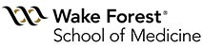

Institute for Regenerative Medicine

WFIRM Summer Scholars Program 2017
Joshua Frase Foundation Namesake Scholar

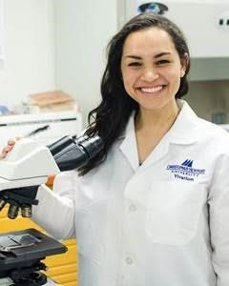
Hayley Premo
Christopher Newport University, Neuroscience

I recently graduated from Christopher Newport University with a Bachelor’s of Science in Neuroscience and a minor in Leadership Studies. I’m a pre-med student and have just finished applying to medical schools. However, research has always been a significant part of my undergraduate different labs, leading projects in both. I’m originally from Winston-Salem so one of the reasons (among many others) that I applied to the WFIRM Summer Scholar program was to be able to come back home for a summer while being able to continue carrying out scientific research. I first became interested in regenerative medicine during one of my neurobiology classes when we began learning about neurodegenerative disorders. I developed an interest in Alzheimer’s Disease in particular and began looking at regenerative medicine as being utilized as a potential treatment. I wanted to learn more about this type of medicine and how it’s evolving when I discovered the WFIRM program. The interdisciplinary and immersive nature of the program seemed like an ideal environment to be introduced to the field of regenerative medicine.

This summer, under the mentorship of Dr. Tracy Criswell, I will be studying the effects of radiation on skeletal muscle progenitor cells. One of the treatments for certain types of cancer, especially for soft tissue sarcomas, is radiation therapy. However, this therapy tends to lead to muscle weakness and a marked decrease in mobility, thus decreasing the quality of life for these patients post-treatment. Although this is a common and consistent issue, the ways in which radiation affects the cellular activities of muscle is still unclear. Therefore, this summer I will be culturing muscle progenitor cells, also called satellite cells, and exposing them to different doses of radiation. After exposure, we will be observing dose-dependent and time-dependent changes in cell morphology, growth, and phenotypic expression. This experiment will hopefully provide some preliminary data regarding the effects of radiation on skeletal muscle progenitor cells and create a foundation on which to build future experiments.

As for my future plans, as I previously mentioned I have just finished the process of applying to medical schools (one of which is Wake Forest!) and will hopefully be admitted into the entering class of Fall 2018. Although I’m sure my areas of interest will change, I’m hoping to go into surgery or geriatrics. In addition, I am planning to spend a few years abroad serving impoverished populations and providing free medical care to those in severe need.

